Lab 7.2.5.4 Configuring IPv6 Addresses on Network Devices

1. Topology

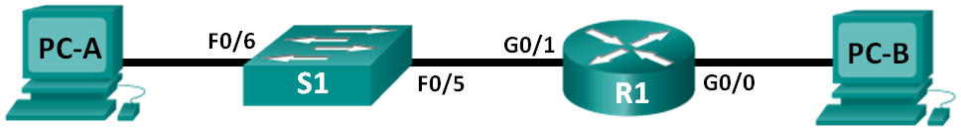

1. Addressing Table

|  |  |  |  |  |
| --- | --- | --- | --- | --- |
| Device | Interface | IPv6 Address | Prefix Length | Default Gateway |
| R1 | G0/0 | 2001:DB8:ACAD:A::1 | 64 | N/A |
| G0/1 | 2001:DB8:ACAD:1::1 | 64 | N/A |
| PC-A | NIC | 2001:DB8:ACAD:1::3 | 64 | FE80::1 |
| PC-B | NIC | 2001:DB8:ACAD:A::3 | 64 | FE80::1 |

1. Objective

Part 1: Set Up Topology and Configure Basic Router and Switch Settings

Part 2: Configure IPv6 Addresses Manually

Part 3: Verify End-to-End Connectivity

1. Background / Scenario

In this lab, you will configure hosts and device interfaces with IPv6 addresses and explore how the all-router multicast group is assigned to a router. You will use **show** commands to view IPv6 unicast and multicast addresses. You will also verify end-to-end connectivity using the **ping** and **traceroute** commands.

1. Set Up Topology and Configure Basic Router and Switch Settings
   1. Cable the network as shown in the topology.
   2. Assign static IPv6 addresses to the PCs.
   3. Configure the router.
      1. Console into the router and enable privileged EXEC mode.

Router> **enable**

Router#

* + 1. Assign the device name to the router.

Router# **config t**

Enter configuration commands, one per line. End with CNTL/Z.

Router(config)#

Router(config)# **hostname R1**

* + 1. Disable DNS lookup to prevent the router from attempting to translate incorrectly entered commands as though they were hostnames.

R1(config)# **no ip domain-lookup**

* + 1. Assign **class** as the privileged EXEC encrypted password.

R1(config)# **enable secret class**

* + 1. Assign **cisco** as the console password and enable login.

R1(config)# **line con 0**

R1(config-line)# **password cisco**

R1(config-line)# **login**

R1(config-line)# **exit**

R1(config)#

* + 1. Assign **cisco** as the VTY password and enable login.

R1(config)# **line vty 0 4**

R1(config-line)# **password cisco**

R1(config-line)# **login**

R1(config-line)# **exit**

R1(config)#

* + 1. Encrypt the clear text passwords.

R1(config)# **service password-encryption**

* + 1. Create a banner that warns anyone accessing the device that unauthorized access is prohibited.

R1(config)# **banner motd # Unauthorized access prohibited! #**

* + 1. Save the running configuration to the startup configuration file.

R1(config)# **exit**

R1# **copy run start**

Destination filename [startup-config]?

Building configuration...

[OK]

* 1. Configure the switch.
     1. Console into the switch and enable privileged EXEC mode.

Switch> **enable**

Switch#

* + 1. Assign the device name to the switch.

Switch# **configure terminal**

Enter configuration commands, one per line. End with CNTL/Z.

Switch(config)#

Switch(config)# **hostname S1**

S1(config)#

* + 1. Disable DNS lookup to prevent the router from attempting to translate incorrectly entered commands as though they were hostnames.

S1(config)# **no ip domain-lookup**

S1(config)#

* + 1. Assign **class** as the privileged EXEC encrypted password.

S1(config)# **enable secret class**

* + 1. Assign **cisco** as the console password and enable login.

S1(config)# **line con 0**

S1(config-line)# **password cisco**

S1(config-line)# **login**

S1(config-line)# **exit**

S1(config)#

* + 1. Assign **cisco** as the VTY password and enable login.

S1(config)# **line vty 0 4**

S1(config-line)# **password cisco**

S1(config-line)# **login**

S1(config-line)# **exit**

S1(config)#

* + 1. Encrypt the clear text passwords.

S1(config)# **service password-encryption**

* + 1. Create a banner that warns anyone accessing the device that unauthorized access is prohibited.

S1(config)# **banner motd # Unauthorized access prohibited! #**

* + 1. Save the running configuration to the startup configuration file.

S1(config)# **exit**

S1# **copy run start**

Destination filename [startup-config]?

Building configuration...

[OK]

1. Configure IPv6 Addresses Manually
   1. Assign the IPv6 addresses to Ethernet interfaces on R1.
      1. Assign the IPv6 global unicast addresses, listed in the Addressing Table, to both Ethernet interfaces on R1.

R1#

R1# **config t**

R1(config)# **interface g0/0**

R1(config-if)# **ipv6 address 2001:db8:acad:a::1/64**

R1(config-if)# **no shutdown**

R1(config-if)# **interface g0/1**

R1(config-if)# **ipv6 address 2001:db8:acad:1::1/64**

R1(config-if)# **no shutdown**

R1(config-if)# **end**

R1#

* + 1. Issue the **show ipv6 interface brief** command to verify that the correct IPv6 unicast address is assigned to each interface.

R1# **show ipv6 interface brief**

Em0/0 [administratively down/down]

unassigned

GigabitEthernet0/0 [up/up]

FE80::D68C:B5FF:FECE:A0C0

2001:DB8:ACAD:A::1

GigabitEthernet0/1 [up/up]

FE80::D68C:B5FF:FECE:A0C1

2001:DB8:ACAD:1::1

<output omitted>

* + 1. Issue the **show ipv6 interface g0/0** command. Notice that the interface is listing two Solicited Nodes multicast groups, because the IPv6 link-local (FE80) Interface ID was not manually configured to match the IPv6 unicast Interface ID.

**Note**: The link-local address displayed is based on EUI-64 addressing, which automatically uses the interface Media Access Control (MAC) address to create a 128-bit IPv6 link-local address.

R1# **show ipv6 interface g0/0**

GigabitEthernet0/0 is up, line protocol is up

IPv6 is enabled, link-local address is FE80::D68C:B5FF:FECE:A0C0

No Virtual link-local address(es):

Global unicast address(es):

2001:DB8:ACAD:A::1, subnet is 2001:DB8:ACAD:A::/64

Joined group address(es):

FF02::1

FF02::1:FF00:1

FF02::1:FFCE:A0C0

MTU is 1500 bytes

<output omitted>

* + 1. To get the link-local address to match the unicast address on the interface, manually enter the link-local addresses on each of the Ethernet interfaces on R1.

R1# **config t**

Enter configuration commands, one per line. End with CNTL/Z.

R1(config)# **interface g0/0**

R1(config-if)# **ipv6 address fe80::1 link-local**

R1(config-if)# **interface g0/1**

R1(config-if)# **ipv6 address fe80::1 link-local**

R1(config-if)# **end**

R1#

**Note**: Each router interface belongs to a separate network. Packets with a link-local address never leave the local network; therefore, you can use the same link-local address on both interfaces.

* + 1. Re-issue the **show** **ipv6 interface g0/0** command. Notice that the link-local address has been changed to **FE80::1** and that there is only one Solicited Nodes multicast group listed.

R1# **show ipv6 interface g0/0**

GigabitEthernet0/0 is up, line protocol is up

IPv6 is enabled, link-local address is FE80::1

No Virtual link-local address(es):

Global unicast address(es):

2001:DB8:ACAD:A::1, subnet is 2001:DB8:ACAD:A::/64

Joined group address(es):

FF02::1

FF02::1:FF00:1

MTU is 1500 bytes

<output omitted>

What multicast groups have been assigned to interface G0/0?

The all-nodes multicast group (FF02::1) and the Solicited Nodes multicast group (FF02::1:FF00:1).

* 1. Enable IPv6 routing on R1.
     1. Enable IPv6 routing on R1 using the **IPv6 unicast-routing** command.

R1 # **configure terminal**

R1(config)# **ipv6 unicast-routing**

R1(config)# **exit**

R1#

*Dec 17 18:29:07.415: %SYS-5-CONFIG_I: Configured from console by console

* + 1. Use the **show ipv6 interface g0/0** command to see what multicast groups are assigned to interface G0/0. Notice that the all-router multicast group (FF02::2) now appears in the group list for interface G0/0.

**Note**: This will allow the PCs to obtain their IP address and default gateway information automatically using Stateless Address Autoconfiguration (SLAAC).

R1# **show ipv6 interface g0/0**

GigabitEthernet0/0 is up, line protocol is up

IPv6 is enabled, link-local address is FE80::1

No Virtual link-local address(es):

Global unicast address(es):

2001:DB8:ACAD:A::1, subnet is 2001:DB8:ACAD:A::/64 [EUI]

Joined group address(es):

FF02::1

FF02::2

FF02::1:FF00:1

MTU is 1500 bytes

<output omitted>

* + 1. Now that R1 is part of the all-router multicast group, re-issue the **ipconfig** command on PC-B. Examine the IPv6 address information.

Why did PC-B receive the Global Routing Prefix and Subnet ID that you configured on R1?

R1 G0/0 is now part of the All-router multicast group, FF02::2. This allows it to send Router Advertisement (RA) messages with the Global Network Address and Subnet ID information to all nodes on the LAN.

1. Verify End-to-End Connectivity
   * 1. From PC-A,ping **FE80::1**. This is the link-local address assigned to G0/1 on R1.

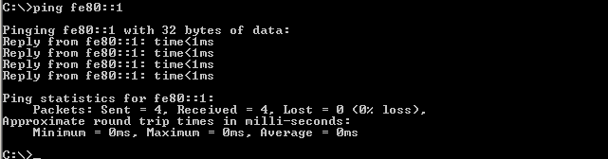

**Note**: You can also test connectivity by using the global unicast address, instead of the link-local address.

* + 1. Use the **tracert** command on PC-A to verify that you have end-to-end connectivity to PC-B.

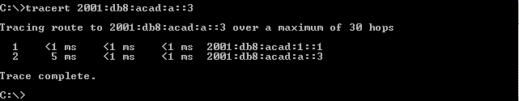

* + 1. From PC-B, ping PC-A.

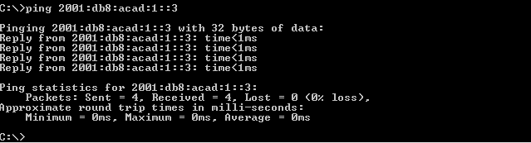

* + 1. From PC-B, ping the link-local address for G0/0 on R1.

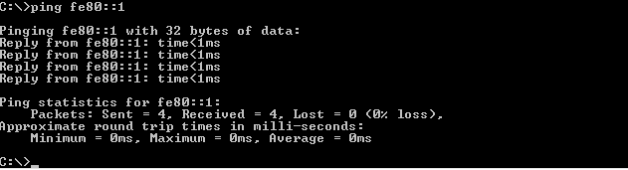

**Note**: If end-to-end connectivity is not established, troubleshoot your IPv6 address assignments to verify that you entered the addresses correctly on all devices.